Technical File
DRAFT

Document ID: TF-SG-ECLIPSEPRO-SERIES
Revision: Rev. 1.0.
Date: November 11, 2025
Previous Revision: TF-SG-ECL-001 Rev 2.1 (14/07/2025)
Revision | Date | Author | Description Of Change
1.0 | 11/11/2025 | M. Grāvītis | This document supersedes TF-SG-ECL-001. It consolidates all EclipsePro product lines...

Product: EclipsePro Series Solar Eclipse Glasses
Manufacturer: SIA “Gravitis Enterprise Limited"
Manufacturer Address: Lauku iela 7-4, Cēsis, LV-4101, Latvia
Regulation: (EU) 2016/425, Category II PPE
Standard: EN ISO 12312-2:2015(E)
Email: support@absoluteeclipse.com

Table of Contents
1. COVER LETTER 5
Manufacturing Sites: 5
2. PRODUCT DESCRIPTION 6
2.1 EclipsePro Paper Series 7
2.2 EclipsePro Plastic Series 8
2.2.1 Model: EGP-FIT (Oversized Fit-Over) 8
2.2.2 Model: EGP-MOD (Modular Magnetic System) 8
2.2.3 Model: EGP-CLP (Clip-On) 9
2.2.4. Model: EGP-GLW (Glow-in-the-Dark) 9
2.3 EclipsePro Filter Sheet 10
2.3.1 Model: EFS-SHT (Filter Sheet) 10
2.4 Equivalency of Protection 10
3. DESIGN AND MANUFACTURING INFORMATION 11
3.1 Technical Drawings and Specifications 11
3.1.1 EclipsePro Paper Series 11
11
3.1.2 EclipsePro Plastic Series 12
3.1.2.1 Model: EGP-FIT (Oversized Fit-Over) 12
3.1.2.2 Model: EGP-MOD (Modular Magnetic System) 12
3.1.2.4 Model: EGP-GLW (Glow-in-the-Dark) 13
3.1.3 EclipsePro Filter Sheet 13
3.1.4 Critical Design Requirements (Applicable Across All Relevant Products) 13
3.2 Manufacturing Process Specifications 15
3.2.1 Primary Manufacturing & Sub-Assembly (Cangnan County Qiwei Craft Co., Ltd., China) 15
3.3 Control of Optional Decorative Artwork and Branding 17
4.0 INSTRUCTIONS FOR USE (IFU) & MARKING STRATEGY 18
4.1 Marking & Information Location Matrix 18
4.2 Justification for Differentiated Marking Strategy 18
4.3 Instruction Documentation (Physical & Master) 19
4.4 Digital Information System (QR Code & Website) 19
4.5 Regulatory Compliance Confirmation 20
5. PRODUCT IDENTIFICATION & TRACEABILITY 21
5.1 Traceability System Specification 21
6. MATERIALS DOCUMENTATION & RISK ASSESSMENT 22
6.1 Complete Material Specifications with Test Reports 22
6.2 Essential Health and Safety Requirements (EHSR) Assessment 22
6.3 Material Risk Assessment Conclusion 23
7. QUALITY CONTROL PROCEDURES 24
7.1 Primary Manufacturing & Sub-Assembly Quality Control (Cangnan County Qiwei Craft Co., Ltd., China) 24
7.1.1 Common Quality Control Steps (Applicable to All Product Lines) 24
7.1.2 Product Line-Specific Quality Control Steps 24
7.2 Final Assembly, Inspection & Packaging (SIA Gravitis Enterprise Limited, Latvia) 25
8. LIST OF APPLIED STANDARDS AND LEGISLATION 27
8.1 Applied Legislation and Key Harmonised Standard 27
8.2 Supporting Standards and Regulations 27
8.2.1 Chemical Safety & Material Composition 27
8.2.2 Product-Specific Standards 27
8.3 Summary of Required Information & Markings 27
9. EU DECLARATION OF CONFORMITY 29
10. RESULTS OF DESIGN CALCULATION 30
10.1 Technical Drawings 30
10.2 Material & Component Test Reports 30
10.3 Solar Filter Certification (EN ISO 12312-2:2015) 30
10.4 Regulatory & User Information Documents 30
10.5 Packaging Artwork Specification 31
10.6 Supporting Documentation Summary 31
11. DOCUMENT RETENTION COMMITMENT 32

1. COVER LETTER

Manufacturing Sites:
- Cangnan County Qiwei Craft Co., Ltd., Industrial Zone, Cangnan County, Wenzhou City, Zhejiang Province, China 325800
- SIA Gravitis Enterprise Limited, Lauku iela 7-4, Cēsis, LV-4101, Latvia

In accordance with Regulation (EU) 2016/425 Article 8(3), SIA Gravitis Enterprise Limited shall keep this technical documentation and the EU Declaration of Conformity for a period of 10 years from the date the PPE is placed on the market.

2. PRODUCT DESCRIPTION

This Technical File covers the EclipsePro Series of solar viewing products, a range of Personal Protective Equipment (PPE) designed for the safe, direct observation of the sun.
All products described herein are Category II PPE in accordance with Regulation (EU) 2016/425 and are designed to meet all requirements of the harmonised standard EN ISO 12312-2:2015(E). The intended use for all models is to provide protection for the user's eyes against harmful solar radiation during direct viewing of a solar eclipse.

2.0 Product Identification & Naming Convention
To ensure traceability between this consolidated Technical File (Rev 1.0) and previous documentation (TF-SG-ECL-001 Rev 2.1), the following Model Identification Codes are established.
The "EclipsePro Paper Series" and "EclipsePro Plastic Series" have been reclassified from single product definitions to Product Categories containing distinct models.

New Model ID | Previous Designation (Rev 2.1) | Compliance Status / Explanation
EGP-PAP | EclipsePro Paper Series | Renamed Legacy Product. This model ID is assigned to the standard folding paper glasses previously defined as the sole "Paper Series" product. The physical device is identical.
EGP-HND | N/A (New) | New Model. Handheld mask variant added to the Paper Series category.
EGP-GLW | EclipsePro Plastic Series | Renamed Legacy Product. This model ID is assigned to the Glow-in-the-Dark device previously defined as the sole "Plastic Series" product. The physical device (mold and material) is identical to the one in previous test reports.
EGP-FIT | N/A (New) | New Model. Oversized Fit-Over model added to the Plastic Series category.
EGP-MOD | N/A (New) | New Model. Modular Magnetic System added to the Plastic Series category.
EGP-CLP | N/A (New) | New Model. Clip-On mechanism added to the Plastic Series category.
EGP-SHT | N/A (New) | New Product Line. Solar Filter Sheets added as a standalone component category.

2.1 EclipsePro Paper Series (Cellulose-Based)
This product line consists of solar viewing devices constructed from 250g/m² C1S paperboard.

The standard foldable solar eclipse glasses with temple arms.

2.1.1 Model: EGP-PAP (Standard Glasses)
- Design Variants: Available in Base Shape (SEG-FAB-001), Narrow Shape (SEG-FAB-002), and Eye Hole Variant B (SEG-VAR-001).
- Note: All shape variants maintain identical filter aperture coverage and structural integrity.
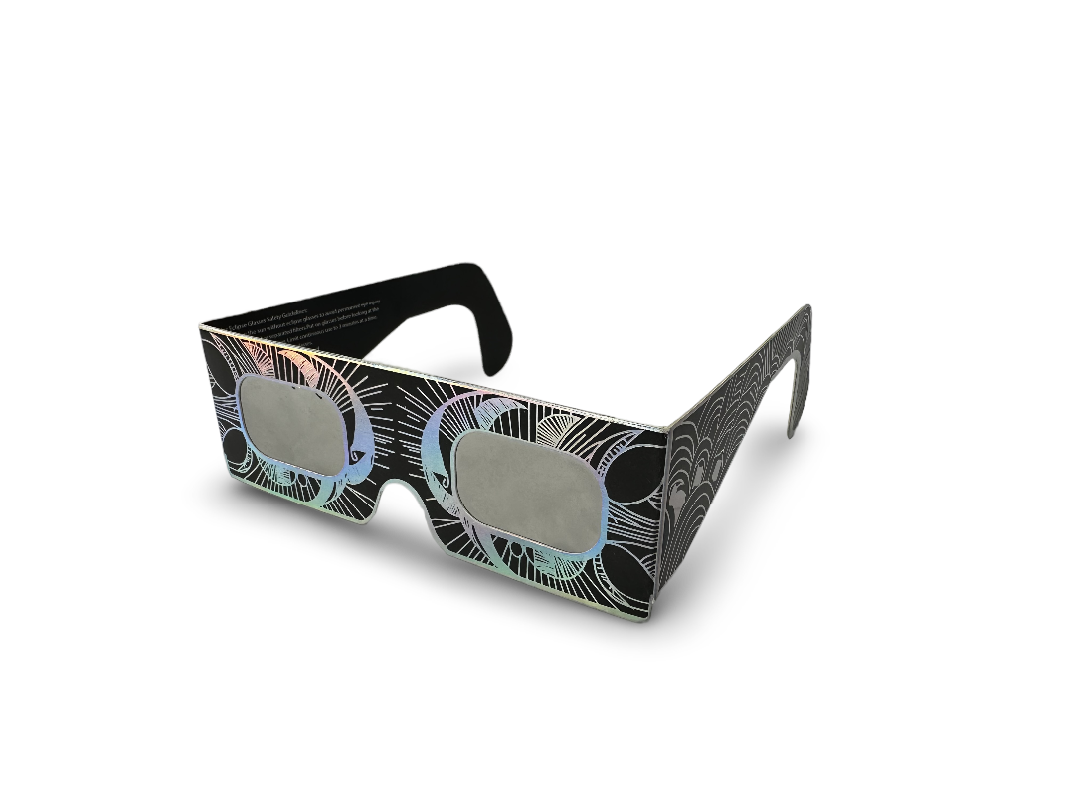
Figure 2.1: Representative base model of the EclipsePro Paper Series.
Design Variants:
The Paper Series is available in multiple fabrication variants which affect the overall dimensions and eye-opening shape, though the core protective filter remains identical. These variants are detailed in the attached technical drawing package (SEG-TDP-001-RevB.pdf) and include:
- Base Shape (Drawing: SEG-FAB-001)
- Narrow Shape (Drawing: SEG-FAB-002)
- Eye Hole Variant B (Drawing: SEG-VAR-001)
Note: The image above illustrates the fundamental construction of the Base Shape. All variants maintain full compliance with the safety requirements of EN ISO 12312-2. Cosmetic artwork applied to the frames varies but does not alter the protective structure, as detailed in Section 3.3.

2.2 EclipsePro Plastic Series (Polymer-Based)
This product line consists of durable, injection-molded solar viewing devices. While all models utilize the same certified solar filter, they feature distinct designs and functionalities.

2.2.1 Model: EGP-FIT (Oversized Fit-Over)
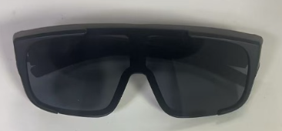
A single-piece frame with an oversized design and large lens area, engineered to be worn comfortably over most prescription glasses.

2.2.2 Model: EGP-MOD (Modular Magnetic System)
A two-part system consisting of a base frame with non-protective clear plano lenses and interchangeable front attachments. The attachments connect securely via magnets. The product is supplied with one solar filter attachment (EN ISO 12312-2) and one standard sunglass attachment (EN ISO 12312-1).


2.2.3 Model: EGP-CLP (Clip-On)
A frameless device consisting of two solar filter lenses joined by a spring-loaded clip mechanism, designed to attach directly to the nose bridge of a user's existing prescription eyewear.
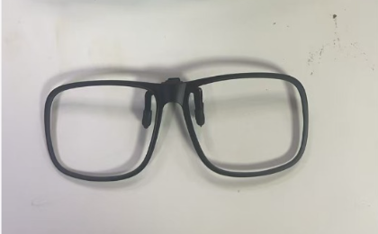

2.2.4. Model: EGP-GLW (Glow-in-the-Dark)
This product line is constructed from a durable, injection-molded polypropylene homopolymer. It serves as a more robust model with a fixed, standardized design, offering enhanced reusability.
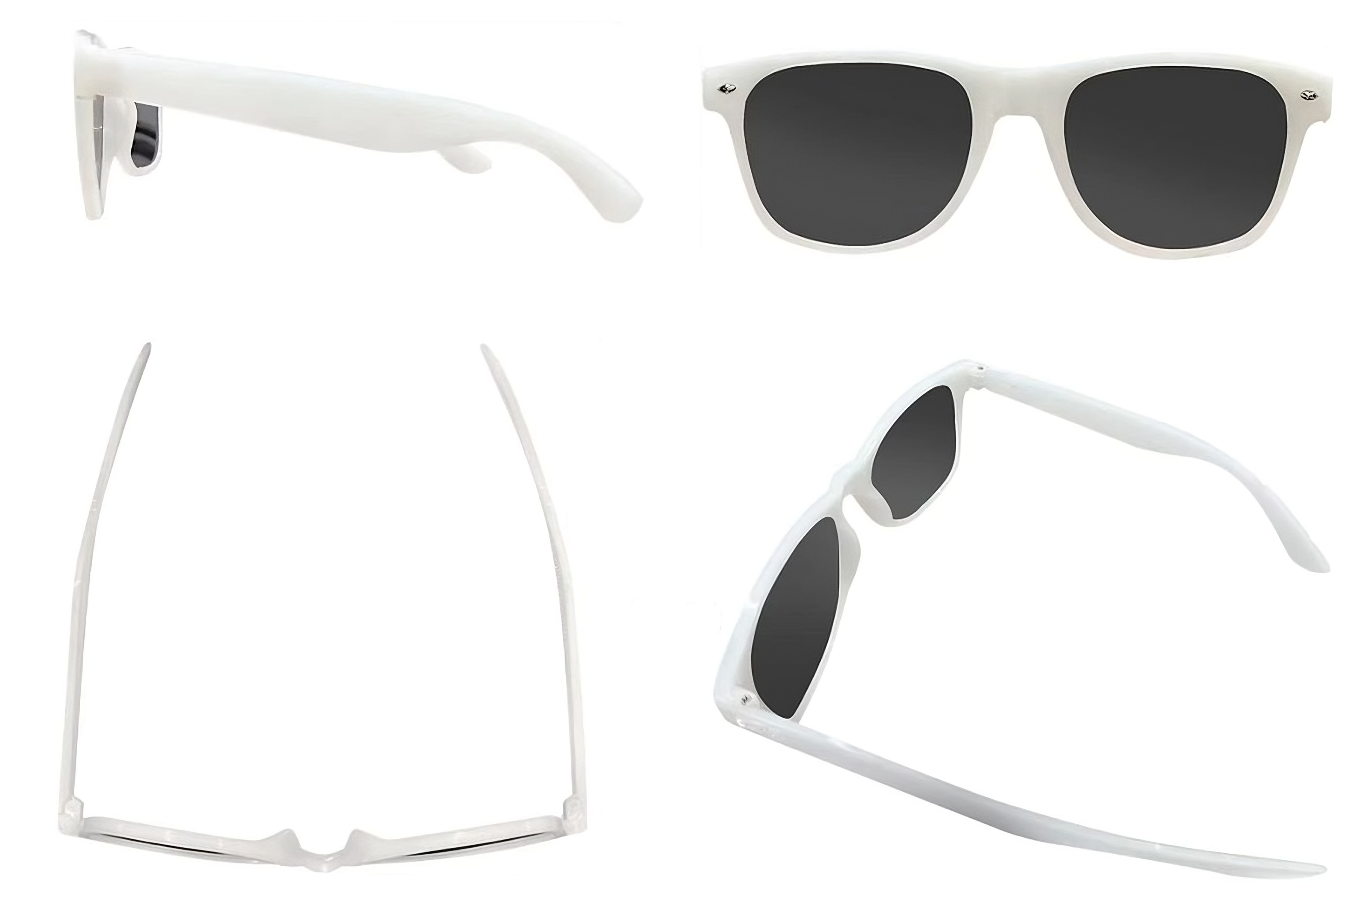
Figure 2.2: Representative model of the EclipsePro Plastic Series.
Note: The image above illustrates the fundamental construction and fixed form factor of the EclipsePro Plastic Series EGP-GLW. It is shown without markings for illustrative clarity. Cosmetic finishes or pad-printed branding may vary but do not alter the protective structure, as detailed in Section 3.3 of this file.

2.3 EclipsePro Filter Sheet

2.3.1 Model: EGP-SHT (Filter Sheet)
Supplied as a standalone component for custom applications. Its intended use requires integration by the end-user into a suitable frame or viewing device that completely shields the eyes from all peripheral sunlight.
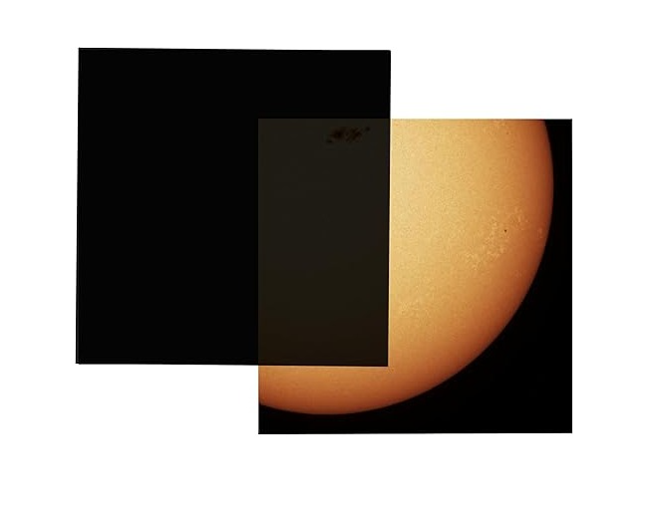

2.4 Equivalency of Protection
While the models differ in frame material and durability, both the Paper Series and the Plastic Series provide the identical level of protection against harmful solar radiation. Both lines utilize independently certified solar filter and are fully compliant with all safety performance requirements of EN ISO 12312-2:2015.

3. DESIGN AND MANUFACTURING INFORMATION

3.1 Technical Drawings and Specifications
This section details the design specifications for all product lines within the EclipsePro Series. Each product and its significant variants are controlled by a dedicated Technical Drawing Package (TDP) as listed below.

3.1.1 EclipsePro Paper Series
- Document Reference: SEG-TDP-001-RevB.pdf
- Status: FOR NOTIFIED BODY SUBMISSION
- Drawing Package Contents:
  - SEG-ASSY-001: Assembly Drawing
  - SEG-MRK-001: Marking Specification
  - SEG-FAB-001: Fabrication - Base Shape
  - SEG-FAB-002: Fabrication - Narrow Shape
  - SEG-VAR-001: Fabrication - Base Shape - Eye Hole Variant B
- Key Dimensions (from Technical Drawings):
  - Overall Dimensions (Base Shape): 415mm width × 145mm height
  - Frame Thickness: 300g/m² cardboard
- Packaging Specifications:
  - PKG-PAPERSERIES-5PK-OUTER-001: Artwork for 5-Unit Pack
  - PKG-PAPERSERIES-10PK-OUTER-001: Artwork for 10-Unit Pack

3.1.2 EclipsePro Plastic Series
The Plastic Series consists of several models with unique designs. Each is controlled by its own drawing package.

3.1.2.1 Model: EGP-FIT (Oversized Fit-Over)
- Document Reference: TDP-SG-EGP-FIT-RevA.pdf
- Status: FOR NOTIFIED BODY SUBMISSION
- Drawing Package Contents:
  - EGP-FIT-MRK-001: Marking Specification
  - EGP-FIT-ASSY-001: Assembly Drawing
  - EGP-FIT-FAB-001: Fabrication - Main Frame
- Key Dimensions (from Technical Drawings):
  - Overall Width: [e.g., 155mm] # TODO
  - Frame Height: [e.g., 52mm] # TODO
  - Frame Thickness: [e.g., 2.2mm (nominal)] # TODO
- Packaging Specification:
  - PKG-PLASTIC-SERIES-1PK-OUTER-001: Artwork for Single Unit Packaging

3.1.2.2 Model: EGP-MOD (Modular Magnetic System)
- Document Reference: TDP-SG-EGP-MOD-RevA.pdf
- Status: FOR NOTIFIED BODY SUBMISSION
- Drawing Package Contents:
  - EGP-MOD-MRK-001: Marking Specification (Base Frame & Attachments)
  - EGP-MOD-ASSY-001: Assembly Drawing (Full System)
  - EGP-MOD-FAB-001: Fabrication - Base Frame & Clear Lenses
  - EGP-MOD-FAB-002: Fabrication - Solar Filter Attachment
  - EGP-MOD-FAB-003: Fabrication - Sunglass Attachment
- Key Dimensions (from Technical Drawings):
  - Base Frame Width: [e.g., 145mm] #TODO
  - Magnetic Attachment Height: [e.g., 48mm] #TODO
3.1.2.3 Model: EGP-CLP (Clip-On)
- Document Reference: TDP-SG-EGP-CLP-RevA.pdf
- Status: FOR NOTIFIED BODY SUBMISSION
- Drawing Package Contents:
  - EGP-CLP-MRK-001: Marking Specification
  - EGP-CLP-ASSY-001: Assembly Drawing
- Key Dimensions (from Technical Drawings):
  - Overall Width (Assembled): [e.g., 130mm] # TODO
  - Lens Diameter: [e.g., 50mm] # TODO

3.1.2.4 Model: EGP-GLW (Glow-in-the-Dark)
- Document Reference: TDP-SG-EGP-GLW-RevA.pdf
- Status: FOR NOTIFIED BODY SUBMISSION
- Drawing Package Contents:
  - EGP-GLW-MRK-001: Marking Specification
  - EGP-GLW-ASSY-001: Assembly Drawing
  - EGP-GLW-FAB-001: Fabrication - Main Frame
- Key Dimensions (from Technical Drawings):
  - Overall Width: 140mm
  - Frame Height: 49mm (front view)
  - Frame Thickness: 2.0mm (nominal)

3.1.3 EclipsePro Filter Sheet
- Document Reference: EGP-SHT-TDP-001-Rev-A.pdf
- Status: FOR NOTIFIED BODY SUBMISSION
- Drawing Package Contents:
  - EGP-SHT-MRK-001: Marking Specification for Sheet & Packaging
  - EGP-SHT-FAB-001: Fabrication Dimensions & Tolerances
- Key Dimensions (from Technical Drawings):
  - Sheet Dimensions: [e.g., 210mm x 297mm]
  - Film Thickness: [e.g., 0.12mm]

3.1.4 Critical Design Requirements (Applicable Across All Relevant Products)
- Filter Coverage: Minimum 3mm overlap of the solar filter around all eye openings in spectacle-style products.
- Tolerances: Unless otherwise specified in the respective TDP, general tolerances are: Linear ±0.5mm, Angular ±1°.
- Zero Light Leakage: All designs for finished eyewear (Paper and Plastic Series) ensure no direct light leakage around the filter edges when properly assembled and worn.
- Structural Integrity: Designs ensure structural integrity during normal handling forces. This includes the mechanical strength of the clip mechanism (EGP-CLP) and the magnetic holding force (EGP-MOD), which are further detailed in the EHSR.
- Complete Eye Coverage: All finished eyewear designs ensure full bilateral eye coverage with adequate safety margins. For the EFS-SHT, the IFU explicitly instructs the user on achieving this requirement.

3.2 Manufacturing Process Specifications

3.2.1 Primary Manufacturing & Sub-Assembly (Cangnan County Qiwei Craft Co., Ltd., China)
This stage covers the fabrication of key components and sub-assemblies for all product lines.
- Environmental Controls: Temperature: 20-25°C (±2°C); Humidity: 45-65% RH; Clean work environment with filtered air supply.
- Common Process Steps:
  - Material Receiving & Inspection: Verification of all incoming raw material certificates (polymers, filter film, cardboard, hardware) and dimensional checks against technical drawings.
  - Solar Filter Processing: Die-cutting of certified solar filter film to the specific lens shapes required for all models.
- Product Line Specific Steps:
  - For Paper Series: Automated lamination of filter lenses to die-cut paperboard frames.
  - For Plastic Series (EGP-FIT, EGP-GLW, EGP-MOD): Injection molding of all plastic components (frames, temples, magnetic attachments). Lamination of filter lenses into frame apertures or solar filter attachments.
  - For Clip-On Model (EGP-CLP): Assembly of the bridge-and-clip mechanism. Lamination of filter lenses into the lens holders.
  - For Filter Sheet (EFS-SHT): Cutting of filter film to final sheet dimensions.
- Common Concluding Steps:
  - Quality Control: 100% automated light leak and contamination inspection for all lens/frame assemblies. Visual and dimensional inspection of molded parts and finished sheets.
  - QR Code Application: Activation of the traceability system for each unit or its primary component.
  - Packaging: Bulk protective packaging of all components and sub-assemblies for secure shipment to Latvia.
3.2.2 Final Assembly, Quality Control & Packaging (SIA Gravitis Enterprise Limited, Latvia)
This stage covers the final assembly, inspection, and retail packaging of all finished goods.
- Process Steps:
  - Incoming Inspection: 5% statistical sampling of all components received from the primary assembly stage to verify quality and specifications.
  - Final Assembly & Kitting:
    - (Paper Series): Final precision die press cutting and folding of frames per technical drawings.
    - (Plastic Series - EGP-FIT, EGP-GLW): Assembly of temples to main frames using hinge screws.
    - (Plastic Series - EGP-MOD): Kitting of the base frame with the solar filter attachment and the sunglass attachment into the final retail package.
    - (Plastic Series - EGP-CLP): Final functional testing of the spring mechanism.
    - (Filter Sheet - EFS-SHT): No assembly required. Proceed directly to packaging.
  - Final Quality Control: Director-supervised physical inspection of a statistical sample from every batch. Checks include cosmetic defects, sharpness, structural integrity, and verification of correct model configuration and markings.
  - Packaging & Dispatch: Final retail packaging of each product with all required, model-specific documentation (IFU leaflet) and labeling.

3.3 Control of Optional Decorative Artwork and Branding
This section defines the controlling principles for any and all decorative artwork, customer branding, or promotional markings applied to the EclipsePro Series products. These elements are distinct from and subordinate to the mandatory regulatory markings specified elsewhere in this Technical File.
The application of any such artwork is permitted only if it adheres to the following requirements:
- Positional Constraints:
  - The artwork shall be positioned so that it does not obscure, conflict with, or reduce the legibility of any mandatory regulatory markings as defined in the Marking Specification (e.g., SEG-MRK-001).
  - A non-violable clear space of at least 5mm shall be maintained around all mandatory markings.
- Material Control:
  - All materials used to apply decorative artwork must have documented evidence of compliance with the same EU safety standards as the base product materials.
  - The vegetable oil-based inks used for such artwork shall be from the set verified by SGS test reports SHAEC24022975101, ...103, ...105, and ...107, which are included in this Technical File.
  - Any other materials (e.g., alternative inks, hot stamping foils) may only be used after the manufacturer has obtained and filed complete test reports from an accredited laboratory demonstrating equivalent compliance with REACH and other applicable EU safety standards.
- Manufacturer Responsibility:
  - The legal manufacturer, SIA "GRAVITIS ENTERPRISE LIMITED," bears full responsibility for ensuring any product placed on the market, including all decorative elements, is fully compliant with these controlling principles and Regulation (EU) 2016/425.

4.0 INSTRUCTIONS FOR USE (IFU) & MARKING STRATEGY
This section defines the hierarchical information strategy for the entire EclipsePro Series, ensuring full compliance with Regulation (EU) 2016/425. The strategy provides complete and accessible information to the end-user via four distinct layers: on-product marking, on-packaging marking, a physical Instructions for Use (IFU) leaflet, and a digital platform. The approach is adapted for the unique physical characteristics and intended use of each product line.

4.1 Marking & Information Location Matrix
The physical IFU leaflet serves as the primary, comprehensive guide for all products, repeating and explaining information found elsewhere. The location of mandatory information varies by product line due to differences in physical construction and available surface area.
Information / Marking | EclipsePro Paper Series | EclipsePro Plastic Series (All Models) | EclipsePro Filter Sheet
CE Mark & Notified Body Nr. | On-Product & IFU Leaflet | On-Product & IFU Leaflet | On-Packaging & IFU Leaflet
Standard (EN ISO 12312-2) | On-Product & IFU Leaflet | On-Product & IFU Leaflet | On-Packaging & IFU Leaflet
Manufacturer Name & Address | On-Product & IFU Leaflet | On-Packaging & IFU Leaflet | On-Packaging & IFU Leaflet
Product Model Identification | On-Product & On-Packaging | On-Packaging & IFU Leaflet | On-Packaging & IFU Leaflet
EU Type-Examination Statement | On-Product & On-Packaging | On-Packaging | On-Packaging
QR Code & Unique Serial Number | On-Product | On-Packaging | On-Packaging
Use By Date | Provided Digitally (via QR) | Provided Digitally (via QR) | Provided Digitally (via QR)
Storage Conditions | IFU Leaflet Only | IFU Leaflet Only | IFU Leaflet Only

4.2 Justification for Differentiated Marking Strategy
The variation in marking locations is a necessary adaptation to the fundamental differences between the product lines.
- EclipsePro Paper Series: Constructed from flat, wide paperboard, which provides ample surface area for the application of all mandatory markings directly onto the product.
- EclipsePro Plastic Series: The temple arms of the injection-molded frames are narrower and feature curved profiles. This geometry makes it technically infeasible to legibly and permanently print extensive text (such as the full manufacturer address). In accordance with Regulation (EU) 2016/425 for space-constrained products, this information is moved to the primary packaging and accompanying IFU.
- EclipsePro Filter Sheet: As a flexible, transparent film component, applying permanent, legible markings directly onto the filter surface without compromising the optical viewing area is not feasible. Therefore, all mandatory markings are placed on the protective primary packaging and within the IFU.

4.3 Instruction Documentation (Physical & Master)
To ensure all users have access to critical and model-specific safety information, instructions are provided in multiple formats. Every retail unit includes a printed Instructions for Use (IFU) leaflet with comprehensive safety warnings, usage instructions, and storage conditions tailored to that specific product.
- Languages: English, German, French, Italian, Spanish, Portuguese, and Dutch.
- Document Control: For full traceability, each leaflet is printed with its unique document number, revision, and release date. The document identifiers correspond to the specific product model:
  - Paper Series:
    - IFU-SG-PAPER-SERIES-RevA #TODO
  - Plastic Series:
    - IFU-SG-EGP-FIT-RevA (For Oversized Fit-Over model) # TODO
    - IFU-SG-EGP-MOD-RevA (For Modular Magnetic System) # TODO
    - IFU-SG-EGP-CLP-RevA (For Clip-On model) # TODO
    - IFU-SG-EGP-GLW-RevA (For Glow-in-the-Dark model) # TODO
  - Filter Sheet:
    - IFU-SG-EFS-SHT-RevA # TODO
- Digital Instructions for Use (IFU): The complete and most up-to-date version of the instructions for all models is always digitally available online via the traceability system.

4.4 Digital Information System (QR Code & Website)
The traceability and shelf-life information system is entirely digital.
- Access: Each unit (or its packaging) is assigned a unique serial number, accessible via a scannable QR code and as a human-readable number. Users can access product-specific data by scanning the code or by manually entering the serial number at verify.absoluteeclipse.com.
- Information Provided: The system provides the product’s official Use By date, its manufacturing date, and a link to the complete digital IFU and EU Declaration of Conformity (DoC). This system is detailed in Section 5.1.

4.5 Regulatory Compliance Confirmation
This multi-layered and differentiated information strategy ensures full compliance with Regulation (EU) 2016/425, Article 8, and Annex II. The justified approach for each product line guarantees that all mandatory information remains clear, accessible, and permanently available to the end-user throughout the product's lifecycle.

5. PRODUCT IDENTIFICATION & TRACEABILITY

5.1 Traceability System Specification
Identification Method: Per-Unit Serial Number
Example: 9005585
The traceability system is based on a unique serial number assigned to every individual unit, replacing traditional batch marking. This serial number is accessible as both a scannable QR code and a human-readable number. Users can access the product's unique information by either scanning the QR code or by manually entering the serial number at verify.absoluteeclipse.com.

QR Code and Serial Number Location:
- EclipsePro Paper Series: The unique QR code and serial number are applied directly to each individual product frame.
- EclipsePro Plastic Series: Due to on-product space constraints, the unique QR code and serial number are applied to the primary retail packaging.

Each unique serial number provides access to a digital record containing:
- Manufacturing Date and the official Use By Date.
- Product model variant identification.
- Link to the complete digital Instructions for Use (IFU) and EU Declaration of Conformity (DoC).
- Verification of key quality control checks.
- Company contact information for compliance documentation.
- Material traceability reference numbers.

Traceability Chain:
The system creates a verifiable link from raw material supplier batches through internal production records to the unique serial number assigned to each finished product. This complete chain is stored digitally for the required 10-year retention period.
This system ensures individual product traceability and satisfies the information and traceability requirements of Regulation (EU) 2016/425 Article 8(5).

6. MATERIALS DOCUMENTATION & RISK ASSESSMENT

6.1 Complete Material Specifications with Test Reports
All materials used in the EclipsePro Series have been selected for innocuousness and are verified for compliance with applicable EU safety regulations through test reports from internationally accredited laboratories.
The material compliance documentation is organized into a modular system of annexes to ensure maximum clarity and traceability for each distinct product model. The system is indexed by the following master summary document:
- TF-SG-ECLIPSEPRO-SERIES-AnnexB: Material Compliance Summary and Index
This master annex serves as the primary index and directs to the subordinate annexes which contain the detailed Material Compliance Summaries and corresponding evidence for each specific product.

Note on Test Report Naming and Scope: The solar filter material is identical across all product variants. The test reports from ICS Laboratories (series T18671) confirm its compliance. Some reports may refer to internal development product names (e.g., "Absolute Eclipse Glow in the Dark Solar Glasses"); however, they document the testing of the final, certified filter component used in all EclipsePro Series models.

6.2 Essential Health and Safety Requirements (EHSR) Assessment
In accordance with Annex II of Regulation (EU) 2016/425, a comprehensive and systematic risk assessment has been conducted to identify all relevant hazards for the EclipsePro Series. The harmonised standard EN ISO 12312-2:2015 has been used to presume conformity with the relevant EHSRs it covers.
The complete, detailed analysis demonstrating compliance with each applicable requirement is documented in the formal checklist attached to this Technical File:
- Primary Record: Annex A: Essential Health and Safety Requirements (EHSR) & Risk Assessment Checklist (Document ID: TF-SG-ECL-001-AnnexA)
This Annex serves as the definitive record of the EHSR assessment.
Summary of Key Risks and Control Strategies
The assessment confirmed that the primary risks associated with this type of PPE have been fully addressed through a multi-layered control strategy:
- Hazard: Non-ionising Solar Radiation.
  - Control: Use of a specialized polymer solar filter, certified by an accredited laboratory to meet all spectral transmittance requirements of EN ISO 12312-2:2015.
- Hazard: Chemical Hazards from Materials.
  - Control: All constituent materials (polymers, paperboard, inks, foils, adhesives, and hardware) have been selected for innocuousness and their compliance verified against EU regulations (e.g., REACH SVHC) through test reports from accredited laboratories, as detailed in the Annex B series.
- Hazard: Light Leakage and Physical Integrity.
  - Control: Robust frame designs that ensure full eye coverage and a minimum 3mm filter overlap are documented in technical drawings. Risks are further mitigated by automated manufacturing controls and final quality control procedures.
- Hazard: Misuse and Lack of Information.
  - Control: Provision of clear, permanent markings and a comprehensive, multi-language printed Instructions for Use (IFU) leaflet with every unit, as detailed in Section 4.
Assessment Conclusion
All applicable Essential Health and Safety Requirements of Annex II are satisfied through the combination of compliant design, verified materials, controlled manufacturing processes, and comprehensive user information. All identified risks have been reduced to an acceptable level, ensuring the product is safe for its intended use.

6.3 Material Risk Assessment Conclusion
Risk Assessment Conclusion: All materials and components used across the entire EclipsePro Series have been tested by internationally accredited laboratories (SGS, Sinolight, ICS). The complete results, which are detailed in the TF-SG-ECLIPSEPRO-SERIES-AnnexB series of documents, confirm full compliance with the relevant Essential Health and Safety Requirements of Regulation (EU) 2016/425. This includes conformity with Regulation (EC) No 1907/2006 (REACH) for chemical safety and EN ISO 12312-2:2015 for the solar filter's performance and material innocuousness.

7. QUALITY CONTROL PROCEDURES
This section outlines the multi-stage quality control system for the entire EclipsePro Series, ensuring that all products meet design specifications and safety requirements. The process is divided into two key stages: primary manufacturing in China and final assembly/inspection in Latvia.

7.1 Primary Manufacturing & Sub-Assembly Quality Control (Cangnan County Qiwei Craft Co., Ltd., China)
This stage covers the fabrication of components and initial assembly. Quality control is integrated throughout the process, combining automated inspection with specific manual checks.

7.1.1 Common Quality Control Steps (Applicable to All Product Lines)
- Material Receiving Inspection: All incoming raw materials (polymers, filter film, paperboard, hardware) are verified against certificates of conformity and checked for dimensional accuracy and cosmetic defects.
- Solar Filter Processing: Die-cutting of certified solar filter film is monitored for precision. All processed lenses undergo a 100% inspection for scratches, pinholes, or delamination before assembly.
- Contamination Detection System: Automated inspection of frame or component surfaces for cleanliness before filter application. Production is halted if contamination is detected.
- Light Leak Detection System: Every assembled unit (all spectacle-style models) undergoes a 100% automated inspection to ensure zero light transmission around the filter-frame seal. Any unit failing this test is automatically rejected and segregated.

7.1.2 Product Line-Specific Quality Control Steps
- For Paper Series:
  - Automated Lamination Control: The machine performing automated lamination of the filter to the paperboard frame uses a positioning control system with a tolerance of ±1mm. Production is halted if the tolerance is exceeded.
- For Plastic Series (EGP-FIT, EGP-GLW):
  - Injection Molding QC: Molded parts are subject to statistical inspection for defects such as flash, short shots, or warping.
  - Hinge Function Check: A sample of assembled frames is tested to ensure smooth and secure temple arm movement.
- For Plastic Series (EGP-MOD - Modular System):
  - Component Fit & Alignment: The base frame, solar attachment, and sunglass attachment are tested for proper fit, ensuring no gaps or misalignment.
  - Magnetic Force & Polarity Check: The seating, polarity, and retention force of the magnets are verified to ensure a secure and reliable connection.
- For Plastic Series (EGP-CLP - Clip-On):
  - Mechanism Assembly QC: The bridge-and-clip spring mechanism is tested for smooth operation and correct tension.
  - Lens Alignment: Assembled units are checked to ensure the two solar filter lenses are correctly aligned and coplanar.
- For Filter Sheet (EFS-SHT):
  - Dimensional Verification: Sheets are checked against the specified dimensions and tolerances.
  - Full Surface Inspection: Each sheet is inspected for any surface defects, scratches, or pinholes across its entire area.

7.2 Final Assembly, Inspection & Packaging (SIA Gravitis Enterprise Limited, Latvia)
This stage covers the final preparation, inspection, and packaging of all finished goods for the EU market.
- Incoming Inspection: A 5% statistical sampling of all components received from the primary manufacturing stage is conducted to re-verify quality and specifications.
- Final Assembly & Functional Verification:
  - (Paper Series): Final precision die press cutting and folding of frames are performed and checked against technical drawings.
  - (Plastic Series - EGP-FIT, EGP-GLW): Temples are assembled to the main frames; hinge screw torque and function are verified.
  - (Plastic Series - EGP-MOD): The base frame, solar attachment, and sunglass attachment are correctly kitted into the final retail package.
  - (Plastic Series - EGP-CLP): A final functional test of the spring mechanism is performed on every unit.
- Final Quality Control (Statistical Sampling):
  - Frequency: 5% of finished, packaged products per batch (minimum 10 units).
  - Inspection Checklist:
    - Product Integrity: Filter integrity (no defects), frame condition (no damage), bond quality. For mechanical models, this includes a final check of the mechanism (hinge, spring, magnets).
    - Information Integrity: Markings are present, correct, and legible. The correct model-specific IFU leaflet is included.
    - Traceability: The QR code is present, scannable, and functional.
- Pass/Fail Criteria:
  - PASS: All automated systems confirm compliance, and visual/functional inspections confirm no safety-affecting defects.
  - FAIL: Any systemic failure or safety-affecting defect triggers a full batch investigation.
  - Critical Defect: Any damage to the solar filter results in an immediate batch hold and root cause analysis.
- Final Approval & Documentation:
  - Approval: Final sign-off for batch release is provided by the Director.
  - Documentation: All quality control records are digitally linked to the batch via the QR traceability system and are retained for a period of 10 years.

8. LIST OF APPLIED STANDARDS AND LEGISLATION
This section identifies the primary legislation, harmonised standards, and other supporting regulations that form the basis for the conformity of the entire EclipsePro Series.

8.1 Applied Legislation and Key Harmonised Standard
These are the foundational regulations for all products within the EclipsePro Series, establishing the legal basis for CE marking as Category II PPE.
- Regulation (EU) 2016/425: on Personal Protective Equipment (PPE). This is the primary legislation governing the design, manufacture, and marketing of the entire product line.
- EN ISO 12312-2:2015(E): Eye and face protection - Sunglasses and related eyewear - Part 2: Filters for direct observation of the sun. Compliance with this key harmonised standard provides the presumption of conformity with the essential health and safety requirements for protection against solar radiation.

8.2 Supporting Standards and Regulations
In addition to the primary legislation, the following regulations and standards are applied to ensure comprehensive safety and compliance across the diverse product range:

8.2.1 Chemical Safety & Material Composition
- REACH Regulation (EC) 1907/2006: Registration, Evaluation, Authorisation and Restriction of Chemicals. Applied universally for the screening of Substances of Very High Concern (SVHC) on all components with potential for user contact, including polymers, paperboard, inks, adhesives, and metallic parts.
- RoHS Directive 2011/65/EU: Restriction of Hazardous Substances. Applied to relevant components, such as the coated neodymium magnets in the EGP-MOD model, to ensure the absence of restricted hazardous substances.

8.2.2 Product-Specific Standards
- GB/T 24999-2018: Coating paper and board. This standard is applied specifically to verify the quality and safety of the coated paperboard used in the EclipsePro Paper Series frame.

8.3 Summary of Required Information & Markings
This list summarises the key information and markings applied across the product system. The specific location and method for each marking are detailed in Section 4 of this technical file.
- CE Mark
- Notified Body Identification Number
- EN ISO 12312-2 Standard Identification
- Manufacturer & Product Identification
- Category II PPE Classification
- Unique Product Identification (Per-unit QR code/serial number)
- Use By Date (Provided digitally via the QR code system)

9. EU DECLARATION OF CONFORMITY

Document Identification: DOC-SG-ECLIPSEPRO-SERIES-001
- This new Declaration of Conformity (DoC) has been created to cover the entire consolidated EclipsePro Series. It formally supersedes the previous document DOC-SG-ECL-001.
Status:
- Prepared and ready for finalization and signing upon the successful completion of the EU type-examination for the expanded product line by the Notified Body.

Scope and Content:
The EU Declaration of Conformity is the sole responsibility of the manufacturer, SIA “Gravitis Enterprise Limited". The document formally declares that the entire EclipsePro Series of products (including all Paper, Plastic, and Filter Sheet models) is in conformity with the provisions of:
- Regulation (EU) 2016/425 on Personal Protective Equipment.
- The relevant harmonised standards and regulations used to demonstrate compliance, as listed in Section 8 of this technical file, specifically:
  - EN ISO 12312-2:2015
  - REACH Regulation (EC) No 1907/2006
  - RoHS Directive 2011/65/EU
The Declaration will include the name and number of the Notified Body and reference the new EU type-examination certificate issued for this entire product series.
Availability:
The final, signed EU Declaration of Conformity will be made available to end-users and authorities via:
- QR Code: Scannable on each product or its packaging.
- Website: Accessible via the traceability portal at verify.absoluteeclipse.com.
- Email Request: Available upon request from support@absoluteeclipse.com.

10. RESULTS OF DESIGN CALCULATION

10.1 Technical Drawings
- EclipsePro Paper Series:
  - SEG-TDP-001 Rev. B - Complete Technical Drawing Package (7 sheets)
- EclipsePro Plastic Series:
  - SEGP-TDP-001 Rev. B – Complete Technical Drawing Package (5 sheets)

10.2 Material & Component Test Reports
A complete matrix of all constituent materials, their specifications, suppliers, and corresponding compliance test reports is consolidated in the following controlled document:
- TF-SG-E-001-AnnexB: Material Compliance Summary
This annex serves as the master list for all material-related compliance documentation and contains the full details for the frame, inks, foils, adhesives, and additives.

10.3 Solar Filter Certification (EN ISO 12312-2:2015)
The solar filter film used in all product variants is certified for compliance with EN ISO 12312-2:2015.
- T18671-01-1 - Solar Filter Compliance Test Report (ICS Laboratories)
- T18671-01-3 - Solar Filter Compliance Test Report (ICS Laboratories)

10.4 Regulatory & User Information Documents
- Instructions for Use (Paper Series):
  - SEG-IFU-Physical-001 Rev. B - Printed Instructions of Use Leaflet
- Instructions for Use (Plastic Series):
  - SEGP-IFU-Physical-001 Rev. B – Printed Instructions of Use Leaflet
- EU Declaration of Conformity:
  - DOC-SG-ECL-001-RevA - EU Declaration of Conformity

10.5 Packaging Artwork Specification
- PKG-PAPERSERIES-5PK-OUTER-001 Rev. A: Outer Carton Artwork (5-Pack)
- PKG-PAPERSERIES-10PK-OUTER-001 Rev. A: Outer Carton Artwork (10-Pack)
- PKG-PLASTIC-SERIES-1PK-OUTER-001 Rev. A: Primary Packaging Artwork (Plastic Series)

10.6 Supporting Documentation Summary
The complete documentation package demonstrates full regulatory compliance through:
- Technical drawing specifications with dimensional tolerances
- International laboratory testing of all materials
- Comprehensive quality control procedures
- Full traceability and marking systems
- EU regulatory compliance verification

11. DOCUMENT RETENTION COMMITMENT
In accordance with Regulation (EU) 2016/425 Article 8(3):
SIA Gravitis Enterprise Limited commits to keeping this technical documentation and the EU Declaration of Conformity for a period of 10 years from the date the PPE is placed on the market. This includes:
- Complete technical file and all revisions
- All supporting test reports and material certifications
- Quality control records and traceability documentation
- Manufacturing process specifications and drawings
- Declaration of Conformity and certification documentation
Document Control:

Person Responsible for Technical Documentation:
Māris Grvitis, Director
SIA Gravitis Enterprise Limited

Approved by: Māris Gravitis, Director
Date: July 14, 2025
Signature:
Notified Body: MTIC Intercert S.r.l. 0068, Via G. Leopardi. 14 - 20123 Milan (MI) – Italy

END OF TECHNICAL FILE Rev. 1.0

